**IOT BASED CHILD SAFETY MONITORING SYSTEM**

**OBJECTIVE:**

The aim of this work is to develop a wearable device for the safety and protection of kids. This objective is achieved by the analysis of physiological signals in conjunction with body position. The physiological signals that are analyzed are galvanic skin resistance and body temperature. Body position is determined by acquiring raw accelerometer data from a triple axis accelerometer.

**SOLUTION ARCHITECTURE:**

* The safety device protects individuals from potential harms and dangers
* A research done by proposed the child safety wearable device using raspberry pi 3.
* The raspberry pi 3 gathers data from pi camera, pulse sensor and sound sensors. Then, send collected data to parents’ smartphones by SMS using GSM shield.
* Images captured from pi camera and children’s location detected by GPS will also be sent to parents’ devices. In another study, designed a wearable smart watch for women security.
* Sensor inside the smartwatch senses the heartbeat of a child or woman who wears it.
* When he/she is exposed to attacks, heartbeat rate will be high.
* When this is detected, alarm sound will be triggered.
* It will then automatically make calls to registered contact and to the nearest police station.
* Based on the location provided by GPS, police will arrive soon at the correct destination.

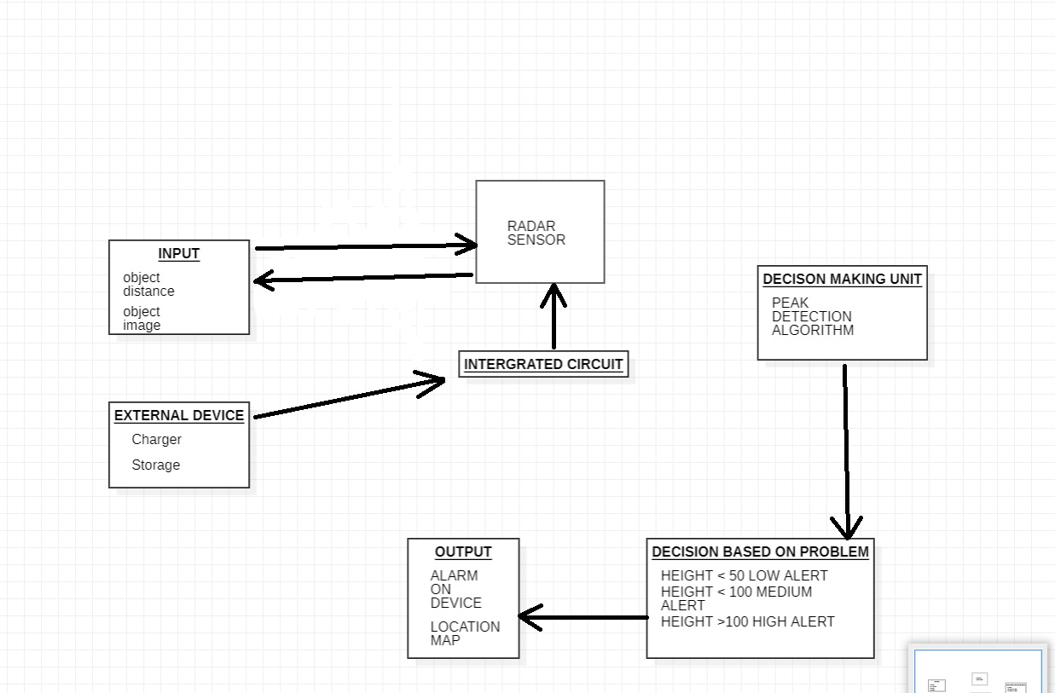

**SCALABILITY:**

• To show the child's actual data with reference values.

• Enable sending of notification if the child is out of location or when the device realizes abnormal conditions/situations.

• To trigger the alarm and enable automatic video recording whenever the emergency button is pressed. Then, emergency notification along with real-time video will be sent to and display in the parents' mobile apps.

• Develop a prototype of IoT wearable smart band connected to parents’ mobile apps so that they can monitor the actual condition of children at anytime and anyplace.

**RELIABILITY:**

University Application process itself being a tedious task students needs lots of endeavour and determination for completing overall application process. • Parents have to work on lots of things when both of them work to run the family.

• It would definitely be easier for parents if they get reliability on safety of children

• This would encourage them to work vigorously on other application components so that the safety of the child would enhance more.

• This system shall be completely operational all hours of the day unless system failure or upgradation work is to be performed.

• Downtime after a failure shall not exceed 24 hours.

**PERFORMANCE:**

* The smart device is able to detect location properly.
* The smart device sends notifications properly.

**SECURITY:**

The Location of the child is trackable only to the authorised people(Parents).

**USABILITY:**

* No training is required to use the smart device
* The device tracks and sends the location within 10 seconds.
* The device sends notification incase of any emergency within 30 seconds